Комплект контрольно-измерительных материалов работан на основе Федерального государственного образовательного стандарта среднего профессионального образования по по специальности 09.02.07 Информационные системы и программирование
Разработчики:
ГБОУ СПО «Богородский политехнический техникум» Преподаватель О.В.Перцева.
(место работы) (занимаемая должность) (инициалы, фамилия)

Одобрено на заседании цикловой методической комиссии
Протокол № от « » 2023г.
Председатель ЦМК ________________________

Одобрено Методическим советом техникума
Протокол № от « » 2023 г.

1. Паспорт комплекта контрольно-измерительных материалов
  - Область применения
Комплект контрольно-измерительных материалов предназначен для контроля и оценки результатов освоения учебной дисциплины “ Иностранный язык в профессиональной деятельноти” программы подготовки специалистов среднего звена по по специальности 09.02.07 Информационные системы
и программирование В целях освоения содержания учебной дисциплины “ Иностранный язык в профессиональной деятельности” разработаны задания для оценки усвоения дисциплины. Задания составлены с целью
обеспечения достижения студентами следующих результатов:

Цель и планируемые результаты освоения дисциплины:

Код ПК, ОК | Умения | Знания
ОК.01  ОК.04  ОК.06  ОК.10  ЛР 1  ЛР 5  ЛР 6  ЛР 8  ЛР 9  ЛР 12 | - - общаться устно и письменно на иностранном языке на профессиональные и повседневные темы;  - - переводить (со словарем) иностранные тексты профессиональной направленности;  - - самостоятельно совершенствовать устную и письменную речь, пополнять словарный запас | лексический (1200-1400 лексических единиц) и грамматический минимум, необходимый для чтения и перевода (со словарем) иностранных текстов профессиональной направленности

2. СТРУКТУРА И СОДЕРЖАНИЕ УЧЕБНОЙ ДИСЦИПЛИНЫ
2.1. Объем учебной дисциплины и виды учебной работы

Вид учебной работы | Объем часов
Всего объем образовательной нагрузки | 190
Промежуточная аттестация форме дифференцированного зачета | —
Самостоятельная работа | 2
Работа обучающихся во взаимодействии с преподавателем:
всего занятий | 188
уроков | —
лабораторных занятий | —
практических занятий | 186
курсовых работ (проектов) | —
консультации | 2

2.2 Тематический план и содержание учебной дисциплины
Наименование  разделов и тем | Содержание учебного материала и формы организации деятельности обучающихся |  | Объём часов | Осваиваемые элементы компетенций
Тема 1. Система образования в России и за рубежом | Содержание учебного материала |  | 12 | ОК 01  ОК 04  ОК 06  ОК 10  ЛР 1  ЛР 5  ЛР 6  ЛР 8  ЛР 9  ЛР 12
 | Не предусмотрено
 | В том числе, практических занятий и лабораторных работ
Лексический материал по теме.
Грамматический материал:
- разряды существительных;
- число существительных;
- притяжательный падеж существительных
Экскурсия «Мой техникум».
Подготовка рекламного проспекта «Техникум»
 | Практические занятия
 | Система образования в России и за рубежом. Экскурсия «Мой техникум». Разряды существительных  Система образования в России и за рубежом. Экскурсия «Мой техникум».Число существительных.  Система образования в России и за рубежом Подготовка рекламного проспекта «Техникум».Число существительных;  Система образования в России и за рубежом. Защита презентаций, рекламных проспектов.  Система образования в России и за рубежом. Текст "Система образования в России".Притяжательный падеж.  Система образования в России и за рубежом. Текст "Система образования в Британии".Притяжательный падеж. |  | 2  2  2  2  2  2
Тема 2. Различные виды искусств. Мое хобби. | Содержание учебного материала |  | 12 | ОК 01  ОК 04  ОК 06  ОК 10  ЛР 1  ЛР 5  ЛР 6  ЛР 8  ЛР 9  ЛР 12
 | Не предусмотрено
 | В том числе, практических занятий и лабораторных работ
Лексический материал по теме.
Грамматический материал:
- разряды прилагательных;
- степени сравнения прилагательных;
- сравнительные конструкции с союзами
Контрольная работа № 1 (1 час)
 | Практические занятия
 | Различные виды искусств. Мое хобби..текст Виды искусства. Разряды прилагательных  Различные виды искусств. Мое хобби. Музеи, театры,кино.Степени сравнения прилагательных  Различные виды искусств.Мое хобби. Текст" хобби". Степени сравнения прилагательных  Различные виды искусств.Мое хобби.-рассказ"Мое хобби." Сравнительные конструкции с союзами  Различные виды искусств.Мое хоббию "Мое хобби".-работа с текстом.  Различные виды искусств.Контрольная работа |  | 2  2  2  2  2  2
Тема 3. Здоровье и спорт | Содержание учебного материала |  | 14 | ОК 01  ОК 04  ОК 06  ОК 10  ЛР 1  ЛР 5  ЛР 6  ЛР 8  ЛР 9  ЛР 12
 | Не предусмотрено
 | В том числе, практических занятий и лабораторных работ
Лексический материал по теме.
Грамматический материал:
- разряды числительных;
- употребление числительных;
- обозначение времени, обозначение дат
Проект-презентация «День здоровья»
 | Практические занятия
 | Здоровье и спорт. Разряды числительных.  Здоровье и спорт.Употребление числительных.  Здоровье и спорт. Обозначение времени, обозначение дат.  Здоровье и спорт. Обозначение времени, обозначение дат.Контрольная работа  Здоровье и спорт.  Здоровье и спорт-подготовка проектов "День здоровья.Обозначение времени, обозначение дат.  Здоровье и спорт. Защита проектов-презентация |  | 2  2  2  2  2  2  2
Тема 4. Путешествие. Поездка за границу. | Содержание учебного материала |  | 22 | ОК 01  ОК 04  ОК 06  ОК 10  ЛР 1  ЛР 5  ЛР 6  ЛР 8  ЛР 9  ЛР 12
 | Не предусмотрено
 | В том числе, практических занятий и лабораторных работ
Лексический материал по теме.
Грамматический материал:
- личные, притяжательные местоимения;
- указательные местоимения;
- возвратные местоимения;
- вопросительные местоимения;
- неопределенные местоимения
Сочинение «Как мы путешествуем?»
 | Практические занятия
 | Путешествие. Поездка за границу.Личные, притяжательные местоимения  Путешествие. Поездка за границу.Указательные местоимения.  Путешествие. Поездка за границу-диалог выбор тура. Вопросительные местоимения.  Путешествие. Поездка за границу.диалог в аэропорту.Возвратные местоимения.  Путешествие. Поездка за границу.диалог в гостинице.Грам.упражнения по теме местоимения.  Путешествие. Поездка за границу.-экскурсии.Неопределенные местоимения  Путешествие. Поездка за границу.-экскурсии.Неопределенные местоимения  Путешествие. Поездка за границу.Грамматические упражнения.  Путешествие. Поездка за границу-подготовка проектов.Грам упражнения  Путешествие. Поездка за границу.-защита проектов  Путешествие. Поездка за границу-сочинение «Как мы путешествуем?».Тест Местоимения |  | 2  2  2  2  2  2  2  2  2  2  2
Тема 5. Моя будущая профессия, карьера | Содержание учебного материала |  | 22 | ОК 01  ОК 04  ОК 06  ОК 10  ЛР 1  ЛР 5  ЛР 6  ЛР 8  ЛР 9  ЛР 12
 | Не предусмотрено
 | В том числе, практических занятий и лабораторных работ
Лексический материал по теме.
Грамматический материал:
- видовременные формы глагола;
- оборот thereis/ thereare
Эссе «Хочу быть профессионалом»
Контрольная работа № 2 (1 час)
 | Практические занятия
 | Моя будущая профессия, карьера.-введение новой лексики.Видовременные формы глагола.  Моя будущая профессия, карьера.."Выбор профессии" Видовременные формы глагола.Времена группы Simple.  Моя будущая профессия, карьера. "Выбор профессии". Видовременные формы глагола.Времена группы Simple  Моя будущая профессия, карьера.Текст -Моя будующая профессия програмист".Видовременные формы глагола..Времена группы Simple  Моя будущая профессия, карьера"Моя будующая профессия програмист" Видовременные формы глагола. Времена группы Perfect  Моя будущая профессия, карьера.Проблемы безработтицы .Видовременные формы глагола Времена группы Perfect  Моя будущая профессия, карьера.Проблемы безработтицы .Видовременные формы глагола Времена группы Perfect  Моя будущая профессия, карьера.Проблемы безработтицы .Видовременные формы глагола  Моя будущая профессия, карьера.Системно-обощающее занятие.  Моя будущая профессия, карьера. оборот thereis/ thereare  Моя будущая профессия, карьера. Эссе «Хочу быть профессионалом» |  | 2  2  2  2  2  2  2  2  2  2  2
Тема 6. Компьютеры и их функции | Содержание учебного материала |  | 30 | ОК 01, ОК 04  ОК 06, ОК 10  ЛР 1, ЛР 5  ЛР 6  ЛР 8  ЛР 9  ЛР 12
 | Не предусмотрено
 | В том числе, практических занятий и лабораторных работ
Лексический материал по теме.
Грамматический материал:
- времена группы Continuous;
Работа с текстом «Компьютеры и их функции»
 | Практические занятия
 | Компьютеры и их функции .Времена группы Continuous;  Компьютеры и их функции Времена группы Continuous;  Компьютеры и их функции. Времена группы Continuous;  Компьютеры и их функции. Времена группы Continuous;  Компьютеры и их функции. Выполнение грамматических упражнений  Компьютеры и их функции. Выполнение грамматических упражнений  Компьютеры и их функции. Выполнение грамматических упражнений  Компьютеры и их функции. Выполнение грамматических упражнений  Компьютеры и их функции. Выполнение грамматических упражнений  Компьютеры и их функции.  Компьютеры и их функции.  Компьютеры и их функции.  Компьютеры и их функции.  Компьютеры и их функции.  Компьютеры и их функции. |  | 2  2  2  2  2  2  2  2  2  2  2  2  2  2  2
Тема 7. Подготовка к трудоустройству. | Содержание учебного материала |  | 26 | ОК 01, ОК 04  ОК 06, ОК 10  ЛР 1  ЛР 5  ЛР 6  ЛР 8  ЛР 9  ЛР 12
 | Не предусмотрено
 | В том числе, практических занятий и лабораторных работ
Лексический материал по теме.
Грамматический материал:
- сложное подлежащее;
- сложное дополнение
Работа с текстом «Подготовка к трудоустройству: составление и заполнение документации»
 | Практические занятия
 | Подготовка к трудоустройству .Сложное подлежащие  Подготовка к трудоустройству.Сложное подлежащие  Подготовка к трудоустройству. Сложное подлежащие  . Подготовка к трудоустройству.Сложное дополнение  Подготовка к трудоустройству.Сложное дополнение  Подготовка к трудоустройству.Сложное дополнение  Подготовка к трудоустройству  Подготовка к трудоустройству  Подготока к трудоустройству  Подготовка к трудоустройству  Подготовка к трудоустройству  Подготовка к трудоустройству  Подготовка к трудоустройству |  | 2  2  2  2  2  2  2  2  2  2  2  2  2
Тема 8. Правила телефонных переговоров | Содержание учебного материала |  | 22 | ОК 01, ОК 04  ОК 06, ОК 10  ЛР 1  ЛР 5  ЛР 6  ЛР 8  ЛР 9  ЛР 12
 | Не предусмотрено
 | В том числе, практических занятий и лабораторных работ
Лексический материал по теме.
Грамматический материал:
- сложносочиненные предложения;
- сложноподчиненные предложения
Работа с текстом «Правила телефонных переговоров»
 | Практические занятия
 | Правила телефонных переговоровСложносочиненные предложения.  Правила телефонных переговоров. Сложносочиненные предложения  Правила телефонных переговоров. Сложноподчиненные предложения.  Правила телефонных переговоров.Сложноподчиненные предложения  Правила телефонных переговоров  Правила телефонных переговоров  Правила телефонных переговоров  Правила телефонных переговоров  Правила телефонных переговоров  Правила телефонных переговоров  Правила телефонных переговоров |  | 2  2  2  2  2  2  2  2  2  2  2
Тема 9. Официальная и неофициальная переписка. | Содержание учебного материала |  | 24 | ОК 01, ОК 04  ОК 06, ОК 10  ЛР 1  ЛР 5  ЛР 6  ЛР 8  ЛР 9  ЛР 12
 | Не предусмотрено
 | В том числе, практических занятий и лабораторных работ
Лексический материал по теме.
Грамматический материал:
- типы придаточных предложений;
- наречия some, any, no, everyи их производные
Работа с текстом «Официальная и неофициальная переписка»
 | Практические занятия
 | Официальная и неофициальная переписка.Типы придаточных предложений Официальная и неофициальная переписка.Типы придаточных предложений  Официальная и неофициальная переписка .Наречия some, any, no, everyи их производные  Официальная и неофициальная переписка .Наречия some, any, no, everyи их производные  Официальная и неофициальная переписка .Наречия some, any, no, everyи их производные  Официальная и неофициальная переписка .Наречия some, any, no, everyи их производные  Официальная и неофициалная переписка  Официальная и неофициалная переписка  Официальная и неофициалная переписка  Официальная и неофициалная переписка  Официальная и неофициалная переписка  Официальная и неофициалная переписка |  | 2  2  2  2  2  2  2  2  2  2  2  2
Самостоятельная работа |  |  | 2
Консультации |  |  | 2
Промежуточная аттестация |  |  | 2
Всего |  |  | 190

3.Формы текущего контроля.

При изучении учебной дисциплины предусмотрены следующие виды текущего контроля знаний обучающихся:

Устный опрос – контроль, проводимый после изучения материала в виде ответов на вопросы, позволяет не только проконтролировать знание темы урока, но и развивать навыки свободного общения, правильной устной речи. Проводится в форме беседы, дискуссии или вопросно-ответного метода.
Письменный опрос - контроль, проводимый в форме вопросно-ответного метода( может проводиться также в форме теоретического диктанта или блиц- опроса).

Самостоятельная работа студентов

Текущий контроль проводится на любом из видов учебных занятий. Его результаты учитываются в промежуточной аттестации. В конце семестра проводится директорская контрольная работа.
Тип ( вид) задания | Проверяемые результаты освоения учебной дисциплины | Критерии оценки
Устный опрос | Личностные результаты  Предметные результаты | За правильный ответ ставится положительная оценка
Письменный опрос | Личностные результаты  Предметные результаты |  | «5»- 100 - 90% правильных ответов  «4» - 89 – 75% правильных ответов  «3»- 74 – 55% правильных ответов  «2» -54 -% и менее правильных ответов
Диктант | Личностные результаты  Предметные результаты |  | 90-100% правильных ответов = 5 (отлично);  70-85% правильных ответов = 4 (хорошо)  50% - 65% правильных ответов = 3 (удовлетворительно)  Менее 50% правильных ответов – 2 ( неудовлетворительно)
Самостоятельная работа студентов | Метапредметные результаты  Личностные результаты  Предметные результаты |  | Положительная оценка ставится при правильном выполнении 60% задания

4. Комплект материалов для оценки проверяемых результатов освоения учебной дисциплин

Задания для текущего контроля
Проверочная работа №1
1 Работа с текстом
Переведите тексты и выполните задание по тексту

School Curriculum
From Hawaii to Delaware, from Alaska to Louisiana, each of the 50 states in the USA has its own laws regulating education. From state to state some laws are similar, others are not. For example, all states require young people to attend school (the age limits vary: seven to sixteen, six to eighteen, etc.). Though there is no national curriculum in the united States, certain subjects are taught across the country. Almost every elementary school provides instruction in these subjects: mathematics, language arts(a subject that includes reading, grammar, composition and literature), penmanship, science, social studies (a subject that includes history, geography, citizenship and economics), music, art and physical education. In many elementary schools courses in the use of computers have been introduced. And in some cases, a foreign language is offered in the upper elementary school. Not all schools offer any foreign languages, if they do, if they do, it usually lasts for no longer than half a year. In general, it is not necessary to study a foreign language to get a high school diploma. But if one plans to enter a college or university, one should study a foreign language for no less than two years.
penmanship – каллиграфия, чистописание
citizenship - права и обязанности граждан
1 Questions:
- Are the laws regulating education the same across the USA?
- What are the subjects offered in elementary schools?
- What courses have been introduced in elementary schools?
- Is it necessary to study a foreign language to get a high school diploma in the USA?
- How long should a student study a foreign language at high school before entering a college?
2 Напишите кратко о чем текст,главную мысль( не менее 5 предложений)

2 Грамматика
1. Образуйте множественное число имен существительных.

A dog, a ball, a desk, a horse, a fact, a nose, a lip, a mother, a father, a brother, a pen, a pencil,a flower, a kid, a plant, a lemon, a peach, a banana, a brush, a star, a mountain, a tree, a shilling, a king, the waiter, the queen, an eye, a shelf, a box, the city, a boy, the watch, a dress, a toy, the life, a tomato, a secretary, a crowd, the airport, a theatre, the tornado, a shop, the tragedy.
2. Раскрой скобки, употребляя имена существительные во множественном числе.
I have two little (a sister). They are (a twin). They have a lot of (a pencil) and (an album). They like to draw (a house, a tree, a puppy, a kitten, a duck, a chicken and a doll). My sisters cannot draw (a car, a bus, a tram, a ship and an elephant). I help them.
My best friend has three elder (a brother). They are (a student). They have a lot of (an interest). They like to play computer (a game), to see horror (a film), and to collect (a stamp) and a toy (a car). I think their (a hobby) are very interesting.

3. Поставьте правильную форму притяжательного падежа:

- The (children) room is upstairs.
- (Steve) school is very old.
- My (parents) car was not expensive.
- It’s my (neighbour) cat.
- They are our (doctors) glasses.
- (WHO) objective is monitoring the health situation. (WHO = World Health Organization)
- (Mr. Jones) secretary is here.
- The (babies) toys are funny.
- We love (Grandma) cookies.
- The (women) boyfriends are late.

*3 Монолог Описание картинки.
Выберите фотографию и опишите ее.
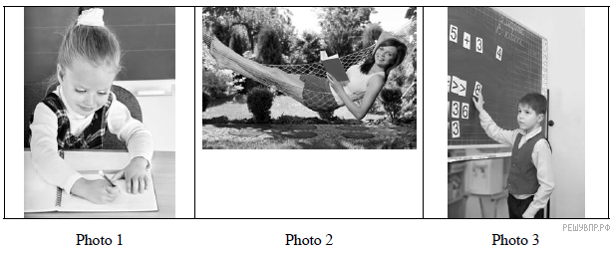

План ответа поможет вам:
— the place
— the action
— the appearance of the person
— whether you like the picture or not
Start with: “I’d like to describe picture № ... . The picture shows …”

Проверочная работа № 2
Задание 1 Работа с текстом
Переведите текст и выполните послетекстовые упражнения.
The Use of Leisure
By the way in which a man uses his leisure his character can be told – more surely in all probability than by the way he does his work. For most men work is necessity in order to gain a living. Vast numbers of men have not even been able to choose what work they would do, but have been forced by economic necessity to take the first job that came their way. But in their leisure time they do what they really want to do and their real selves are reflected in their actions. Some people are completely passive during leisure hours. If such people go out they go to some place f entertainment where no effort is required by them, a cinema or a dancing hall, and if the latter, they do not dance but simply sit and watch others dancing. A different kind of person hurries home from work full of eagerness to begin on some scheme which he has been planning for his leisure time. Perhaps his hobby is carpentry or model engineering, or gardening, or he might wish to write, or to study some subjects in which he is interested. This is the creative type of character. For him his leisure hours are full of promise and he can look back on them ith satisfaction when he reviews what he has achieved in them.
Leisure should be refreshment; it should send a man out with fresh spirits to battle with the problems of life. Sometimes this freshness comes not from doing anything, but by filling one’s mind with fresh springs of beauty. Many a man gets full value from his leisure by contemplating nature, listening to music, or reading noble books. By this sort of occupation he may not have made anything that he can show, but he has none the less recreated his own source of inspiration and made his own mind a richer and fuller treasure house. This is the true use of leisure.

1. Answer the questions
1. Why can a man’s character be told by the way he uses his leisure?
2. Will you choose your job by economic necessity?
3. What types of men are there by the way they spend their leisure?
4. What type of character are you?
5. What do passive people do during leisure hours?
6. How does a creative type of character spend his leisure time?
7. Are you an out-going person or not?
8. What is favorite occupation in leisure time?
9. Why should leisure be refreshment?

2. Find in the text equivalents to the following words and phrases:

досуг
огромное количество
свежие источники красоты
садоводство
полный стремления
место развлечения
собственный источник вдохновения
сокровищница
творческая личность
свое настоящее «Я»
род занятий

2 Грамматика

1 Выбери нужное слово.
- The 1-st of Sерtеmbеr isn't the_(longest/ long) day. 2. The mouse is_ _(smaller/ smallest) than the cat. З. lt is а very_(funniest/ funny) English book. 4. Не is a_(nicest/ niсе) bоу. 5. Му hands are _(сlеаnеr/ clean) than уоur hands. 6. Russia is the_(larger/ largest) country. 7. In the city the rivers аrе_(dirtiеr/ dirty) than in the country. 8. Ted is the_(worse/ worst) pupil in оur class.

2 . Переведите на английский язык.

Майкл старше Питера. Мария самая красивая девочка в классе. Мой старший брат умнее меня. Мой старый друг самый добрый человек в мире. У Марии самые длинные волосы в школе.

Проверочная работа № 3

Задание 1 Работа с текстом
Переведите текст и выполните послетекстовые упражнения.
OLYMPIC GAMES

The world's greatest international sports games are known as the Olympic Games.
The Olympic idea means friendship, fraternity and cooperation among the people of the world. The Olympic Movement proves that real peace can be achieved through sport. The Olympic emblem is five interlinked rings: blue, yellow, black, green and red. Any national flag contains at least one of these colours. The original Olympic Games began in ancient Greece in 776 B.C. These games were part of a festival held every fourth year in honour of God Zeus at the place called Olympia. It was a great athletic festival, including competitions in wrestling, foot racing and chariot racing, rowing and others. The games were for men only. Greek women were forbidden not only to participate but also to watch the Olympics. The first modern Olympic Games were held in Athens in 1896. Then they were resumed in London after the Second World War. Since then the Olympics are held every fourth year in different countries.
The ancient Greeks had no winter sports. Only in 1924 the first Winter Olympic Games were held in France. Now they are being held regularly.

1 QUESTIONS:

- What are the world's greatest sports games?
- What does the Olympic idea mean?
- What is the Olympic emblem?
- When and where did the original Olympic Games begin?
- Did women participate in the games?
- When were the first modern Olympic Games held?
- Are the Olympics held in the same place?
- When did the Winter Olympics Games start being held? Where?
2 Напишите краткое содержание текста,выразив основную мысль текста ( не менее 5 предложений)

- Грамматика
1 Выберите из списка количественные числительные и переведите их.

1.first; 2.eleven; 3.forty; 4.second; 5.two hundred; 6.twenty-first; 7.nineteen; 8.seven; 9.twelfth; 10.third; 11.fourth; 12.eight; 13.seventeen; 14.fifth; 15.nine; 16.one; 17.sixteen;18.tenth; 19.fifty; 20.one hundred and first

2 Выберите из списка порядковые числительные и переведите их.

1.one hundred; 2.fourteen; 3.thirteenth; 4.two 5.ninth; 6.twenty-three; 7.thirty; 8.hundredth; 9.thirty-fifth; 10.seventeenth; 11.forty; 12.twentieth; 13.one million; 14.thousand and hundredth; 15.sixth; 16.ninety; 17.forty-five;18.third; 19.three; 20.eleven

3 Переведите на английский язык.

30 марта,1 ноября,14.30, к15 сентября ,09.15, 2 июля 1999, к 3 августа, 12 мая 2023, 10.45..

*3 Монолог. Описание картинки.
Выберите фотографию и опишите ее.
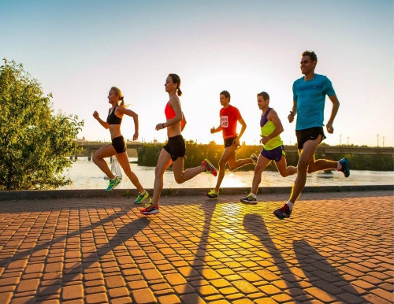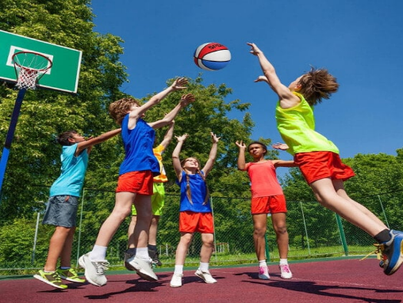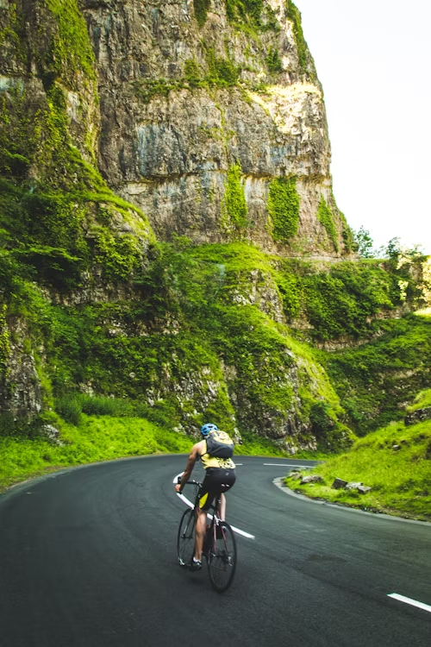
План ответа поможет вам:
— the place
— the action
— the appearance of the person
— whether you like the picture or not
Start with: “I’d like to describe picture № ... . The picture shows …”

Проверочная работа № 4

Задание 1 Работа с текстом
Переведите текст и выполните послетекстовые упражнения.
Airline Travelling

There are three international airports in London: Heathrow, Stansted and Gatwick. Flights inside Britain are called domestic flights, so if you want to travel inside the country go to domestic Departures. At the airline desk you show your ticket and give them your luggage in the usual way. There is also a fast, frequent plane service - the shuttle - between London Heathrow and Manchester, Glasgow, Edinburgh and Belfast. For services to other cities you should ask the airline or travel agents. Families, young people, students and other people can get some tickets cheaper (for train tickets ask about a "Railcard"). Students also have some special offers. If you've arrived by plane, the next thing to do is to get your luggage. Follow the signs to Baggage Reclaim and wait until you see your flight number. Keep your luggage with you till you are asked the label. Go through the Customs. This is the place where officials may search your luggage. There are two channels (passages) for travelers. Those who have more quantity of things than it is allowed to bring must go through the red channel. They have to pay duty (special tax). People with no things to declare go through the green channel without paying duty. You can also buy some things at duty-free shops which are not taxed.

2 Вставьте пропущенные слова и выражения.
When you travel somewhere by plane, first you go to the ..., then you go through ... until you get to the ..., where you wait until your flight is called. Then you go to ..., for example until it is time to board the plane. When you arrive at an airport you first go through ... . Then you reclaim your baggage and go through the ..., where they may check your luggage. Then on the ... you are met by friends and relatives.

- Грамматика
1 Замените выделенные слова личными местоимениями.
1. After dinner Dima had a rest.
2. Many of my friends are my classmates.
3. My father’s name is Ivan Petrovich.
4. Please don’t ask Peter.
5. English people usually have lunch about one o’clock.
6. Ann helps the brother to translate the text.
7. Kate took a book.
8. Our teacher asks us every day.
9. Peter wants to buy a dictionary.
10. My sister has two children.

2 Переведите на английский язык
1. Мой карандаш плохой, дай мне твой.
2. Та книга интересная.
3. Те дома старые.
4. Эти книги новые.
5. Это мой дом, а то твой.

3 Употребите нужное возвратное местоимение
1. I shall ask him…
2. She looked at… in the mirror

4 Вставьте местоимения much/many, (a) little/ (a)few.
- Robert wrote so…letters.
- I drink…coffee
- I don’t eat …mangoes.
- There is…milk in the bottle.
- I have… money, so we can go to the cinema.
- Have you got … time before the lesson?
- There were…new words in the text and Peter spent …time learning them.
- I know French…and I can help you with the translation of this text.
- I want to say…words about my travelling.
- After the lesson everybody fell…tired

5. Вставьте some, any, no
- There are…pictures in the book.
- Are there …maps on the walls?
- There are … old houses in our street.
- Ffter dinner he drank … juice.
- Is there…ham on the plate?

Проверочная работа № 5

Задание 1 Работа с текстом
1 Переведите текст и выполните послетекстовые упражнения.

Do you want to be a computer programmer?
In the future, I may enjoy being a computer programmer because I am keen on trying computer techniques and working with computers is always fun and exciting for me.
People with jobs in the career field of IT use computers, software, networks, servers, and other technology to manage and store data. There is growing demand in various jobs in the field of information technologies nowadays.
It is important to understand that the work of the programmer can be different: some of them work for a small agency, some for a huge company, others are freelance or have their own business. I’d like to work for a big company.
In order to be a successful IT specialist you must possess some skills and personal qualities. The most important ones are the following: being able to think logically, love to solve problems, persistence and patience. A computer programmer must be able to find the most efficient way to solve the problem.
I want my future job be interesting and well-paid. People say that money isn’t everything, but it certainly does help because it gives independence and freedom. I’d like to combine a good satisfying job with a high paying salary.
2 Выпишите преимущества и недостатки профессии
3 Составьте 3 любых вопроса к тексту.

2 Грамматика

1. Откройте скобки и поставьте глаголы в нужную временную форму.

  - If it (to snow), the children will play snowballs.
  - Your brother (to become) much stronger if he took cold baths regularly.
  - You will never finish your work if you (to waste) your time like that.
  - If I (not to know) English, I should not be able to enjoy the poetry.
  - You will never finish your work if you (to waste) your time like that.
  - If I (to have) his telephone number, I should easily settle this matter with him.
  - He never (to phone) you if I had not reminded him to do that.
  - I (not to do) it if you did not ask me.
  - If the fisherman had been less patient, he (not to catch) so much fish.
  - If you had let me know yesterday, I (to bring) you my book.

3. Переведите предложения, определите время сказуемого:

- He often cuts himself.
- What time did John arrive?
- I never forget anything.
- Are you sitting comfortably?
- We drank a lot of Coke at the party.
- It was raining all night.
- The train will leave in a few minutes.
- I put on a clean shirt yesterday.

3. Вставьте is или are.
- There _____ two cups of tea on the table.
- There _____ some milk in the cup.
- There _____ an orange in the salad.
- There _____ six balls in the box.
- There _____ some cheese on the plate.
- There ______ a blue chair at the door.
- There _____ five chicks and a hen on the farm.
- There _____ a table and nine desks in the classroom.
- There _____ a big window to the left of the door.
- There _____ three rooms in our country house.

Проверочная работа № 5

Задание 1 Работа с текстом
1 Переведите текст и выполните послетекстовые упражнения

The Internet as a source of information
Computers play a very important part in our life. They help people in their work and studies. They save us a lot of time. While at school I often made use of the Internet to collect information for my test papers and compositions. Computers give access to a lot of information. It is possible to find data and descriptions, chapters from necessary books… to make a long story short, everything you need. The Internet, a global computer network, which embraces millions of users all over the world, began in the United States in 1969 as a military experiment. It was designed to survive in a nuclear war. Information sent over the Internet takes the shortest path available from one computer to another. Most of the Internet host computers (more than 50%) are in the United States, while the rest are located in more than 100 other countries. Although the number of host computers can be counted fairly accurately, nobody knows exactly how many people use the Internet. There are millions and their number is growing by thousands each month worldwide. Users of computers on a network can send messages to each other, utilizing the same collections of data or information. In many offices and organizations computer messages have replaced messages written on paper, and they are now called e-mail or electronic mail. E-mail is not only fast and easy (if you understand how to use the computer), but it also saves paper and the work of moving paper from one place to another. Workers can send and receive e-mail without leaving their desks and their desktop computers. The Internet may provide businessmen with a reliable alternative to the expensive and unreliable telecommunication systems of their communities. Commercial users can communicate over the Internet with the rest of the world and can do it very cheaply. But saving money is only the first step. If people see that they can make money from the Internet, they increase the commercial use of this network. For example, some American banks and companies conduct transactions over the Internet. So, you see that the Internet is an inseparable part of our life.

1 Ответьте на вопросы .
1.How does the computer help pupils at school?
2.Is it comfortable to send messages to each other?
3. How do the commercial users use the Internet?
4.How do the American banks use the Internet?
5.Why does the American bank use the Internet?

2 Дайте английские эквиваленты.
Экономить время, собирать информацию, найти любую информацию, глобальная компьютерная сеть, послать информацию по Интернету, посылать сообщения друг другу, общаться по Интернету, совершать сделки по Интернету.

- Грамматика
1 Откройте скобки, употребляя глаголы в Present Continuous.
1. Timothy (to feed) his dog.
2. Mr. Jones (to clean) his yard.
3. Nancy (to paint) her kitchen.
4. Our neighbors (to wash) their car.
5. I (to wash) my hair.
6. Who (to fix) your sink?
7. What she (to do) now? – She (to dance).
8.I(to listen) to the radio.
9.She (not to type) her tests.
10.Why you (to shout)?

2 Раскройте скобки, употребляя глаголы в Past Simple или Past Continuous.
1. I (to go) to the cinema at four o’clock yesterday.
2. I (to go) to the cinema when you met me.
3. I (to do) my homework the whole evening yesterday.
4. When the World War (break), John (live) in Holland.
5. I (to work) in the library from five till eight yesterday.
6. I (not to play) the piano at four o’clock yesterday. I (to read) a book.
7. When I (to draw) yesterday, I (to break) two pencils.
8. We (to listen) to an interesting lecture yesterday.
9. They (to get) ready to go out when it (to begin) raining.
10. What you (to do) yesterday? - I (to translate) a very long article.

Проверочная работа № 6

Задание 1 Работа с текстом
1 Перед вами 2 письма , определите какое из них формальное и неформальное. Напишите свое письмо другу, каким оно будет( формальным или неформальным) ?
А) Thank you for your recent letter. It is so wonderful to hear from you! I am very glad that you had a good vacation.
As for me, I also spent a wonderful vacation. First, I lived with my parents in the garden. The weather was hot and I swam a lot with my friends. We played soccer and rode bicycles.
And in August we went to Cyprus with my parents. It is a large island in the Mediterranean with a wonderful climate. We swam in the sea and were lying in the shade of huge eucalyptus trees. We traveled along the mountain paths and played tennis. Anyway, it was a memorable summer.
How did your academic year begin? Are there newcomers in your class? Any new subjects?
I’m sorry, I have to go to the sports section.

В) Educational Testing Service
PO Box 6151
Princeton NY 085411-6151, USA
Dear Sirs,
I am writing to find out the information concerning TOEFL tests. I live in Russia
and as I want to study in one of the US universities, I must take the TOEFL test
to be admitted.
I hope you have TOEFL preparation centres in Moscow where people can be
trained to take the examination well. I will be obliged if you could inform me of
the location of such centres.
In addition to it, I don’t know anything about payment policies and service fees.
I wonder if you could ell me about acceptable forms of payment.
I would you grateful if you send me all the necessary information. I need.
I am looking forward to hearing from you.
Yours faithfully,
Peter Limonov
7F I., 57 Novaya St.

2 Грамматика
1 Откройте скобки, используя конструкцию Complex Object.

- Do you want (they, stay) at the hotel?
- Would you like (I, show) you the sights of the city?
- We expect (she, set) the table by the time we come.
- I want (she, tell) me the news.
- I don't want (they, be late) for dinner.
- He expected (she, invite) him to the party.
- They found (the lecture, be) boring.
- I wish (my mother, buy) the dress by Saturday.
- We considered (he, be) an honest person.
- I know (he, learn) this poem by heart.
2 Переведите на русский язык ,обращая внимание на сложное дополнение.
- They are likely to win the match.
- She is unlikely to be a good actress.
- We are sure to meet you at the station.
- My parents are certain to believe me.
- Los Angeles is sure to be the capital of the world movie production.
- Celebrities are certain to need peace and quiet.
- They are thought to have gone away some days ago.
- The patient is unlikely to follow the doctor’s recommendations.
- This picture is sure to be the best at the exhibition.
- The delegation is reported to be leaving Russia tonight at 11 a.m.

Директорская контрольная работа 1
Часть1. Работа с текстом
Установите соответствие между заголовками A- H и текстами 1-7 . Используйте каждую букву только один раз. В задании один заголовок лишний.
- Last Minute Offer
- Best Catches Without Mistakes
- Package Holiday
- Summer Holiday for Independent Travellers
- Educational Tour
- Green Travel
- Mountain Adventure
- New Opportunities for Underwater Exploration

- La Baume is a 5-tent holiday camping site that caters for tents and caravans. It is divided into two main areas, each with their own pool area and facilities. They are a short walk apart so it is easy to enjoy the benefits of both. La Baume also boasts a small gift shop, a swimwear shop and a supermarket, which offers most of the goods you would expect from a local convenience store.
- Explore the UK and Ireland knowing your guides care as deeply about the environment as they do that you have a blast! SHAMROCKER and HAGGIS specialize in authentic tours of Ireland and Scotland. Locals run the companies with the goal of showing you the best of their lands while making as little negative impact as possible.
- Here's yet another great deal for an Alaska cruise. You'll begin your adventure in Vancouver and call in the ports of Ketchikan and Skagway before disembarking in Seward. If you thought that being able to afford a dream cruise to Alaska was out of reach, think again. Check out that seven-night cruise that starts at only $349 per person, but you have to jump on it fast since the sailing date's just days away.
- Let us pick you up from selected locations for your day at the Kennedy Space Centre! Listen to expert narration from our knowledgeable guides as we stop to get a bird's eye view of the Space Shuttle launch pads. See other shows and exhibits at the Visitor Complex, including a chance to meet a real astronaut at the Astronaut Encounter Show and enjoy the live-action show ‘Mad Mission to Mars 2025.’ Try your hand at a mission control console and take a virtual moonwalk before returning home!
- A dive vacation is much more than someone handing you a tank, transporting you to a dive site and saying ‘Have Fun’. Divers want much more. Today, Aggressor Fleet yachts span the globe in twelve different countries and the list of exotic destinations keeps growing. The yachts have got private staterooms, an onboard chef and a slide film processing lab- amenities that were unheard of on recreational dive boats.
- Experience the centuries-old Inca Trail trek, the most famous of Peru hiking tours. If you seek to explore the culture, history, and the grandeur of the Peruvian Andes, this trip is for you. From the preserved ruins of Machu Picchu to lush clouds forests and snow-covered peaks, this ten-day tour promises the ultimate experience in Peru adventure tour. Whatever itinerary you choose, this vacation is sure to meet your wildest expectations.
- It is not just the spring that offers great fishing. These Boundary Waters lakes and rivers offer excellent fishing opportunities all season long. Our guides live for fishing these waters and will help you eliminate hours of trial and error on the water. They are there to put you on the fish! Not to mention the addition of a camp cook. Wake in the morning to the smell of fresh brewed coffee and breakfast cooking on the fire.

Часть 2 грамматика

Задание 1.Прочитайте приведённый ниже текст. Преобразуйте, если необходимо, слова, напечатанные заглавными буквами в конце строк, так, чтобы они грамматически соответствовали содержанию текста. Заполните пропуски полученными словами.
Jack got out of the car. He __________________ (LOOK) at the engine when another truck stopped by.
Jack, a truck driver, was driving 100 penguins to the New York Zoo. On the freeway his truck suddenly __________________ (BREAK) down. Jack got out of the car. He __________________ (LOOK) at the engine when another truck stopped by. The second truck driver, Peter, asked if __________________ (HE) colleague needed any help. Jack explained that he was taking the penguins to the zoo and asked if Peter could take the penguins to the zoo. Peter agreed. Some hours __________________ (LATE), the Peter drove past Jack, who was still waiting on the freeway for help to come. The penguins, however, __________________ (BE) still in the truck! “I thought I asked you to take __________________ (THAT) penguins to the zoo,” shouted Jack. Peter replied, “I did, but I had some money left, so we’re going to the cinema now.”

Задание 2 . Грамматический тест
Выбери правильный вариант ответа
1. Her surname…..Williams.
A) are B) am C) is

2. Sometimes she……new books in this shop.
A) buys B) buy C) is buying

3. ….. a boy in the room.
A) There is B) Is C) There are

4. This team ….. like a champion yesterday.
A) plays B) played C) is playing

- This school is….. than that University.
A) better B) good C) gooder

6. I have … small dog.
A) the B) – C) a

7.…are you reading now?
A) Which B) What C) When

8. Where …tomorrow?
A) does she go B) will she go C) she go

9. …he often go to the cinema?
A) does B) do C) doing
3 Опишите картинки.

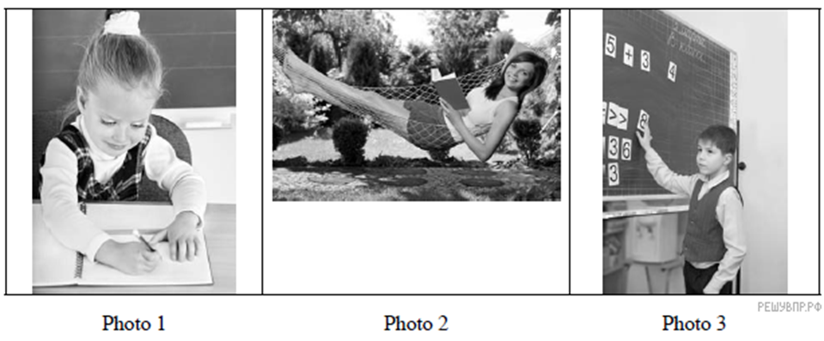
План ответа поможет вам:
— the place
— the action
— the appearance of the person
— whether you like the picture or not
Start with: “I’d like to describe picture № ... . The picture shows …”

Директорская контрольная работа 2
1 Прочитайте текст и заполните пропуски A–F частями предложений, обозначенными цифрами 1–7. Одна из частей в списке 1–7 лишняя. Занесите цифры, обозначающие соответствующие части предложений в таблицу.
Is there enough to say? They only appeared about ten years ago but already they are everywhere, everyone’s got one. They are the wonder of the modern age – mobile phones, or cell phones,A_____________________. Apparently, mobile phones are now used by about 2.5 billion people worldwide, and about one billion new mobile phones are sold every year worldwide. Go back to 1997, and only 100 million were sold. As we can see, the mobile phone business B_____________________. And the developments keep on coming. Once we could only make phone calls; now mobile phones C_____________________ and do many other useful things. Once we had to hold our mobile phones in our hand; now we can use throat microphones. What next? We are told that soon, tiny microphones will be implanted into our lips. We’ll be able to dial numbers just by saying them. But surely we need to ask ourselves: What’s good about this? OK, we can talk to other people almost all the time now – but is that so great? Watch and listen to people when a plane has landed. Anxious D_____________________, dial a number, and then: “It’s me, I’m here. I’ll be there in twenty minutes.” Is this communication? Is this what all these years of technology have brought us to? In the early days of communication there were letters. When they arrived at your house, you knew they had been delivered by a man E_____________________. In those days, people would think very hard before they wrote a letter. You had to have a good reason to write – communication was serious. Now it’s not – people phone each other F_____________________. Once the phone was a way for people far away from each other to talk – now it’s just an excuse to talk.

1. can also be used to take and send photos
2. riding halfway across the country on a horse
3. as Americans call them
4. not understand why they are doing it for
5. just because they can
6. has been developed very quickly
7. fingers immediately switch on the mobile phone

2 Прочитайте приведённый ниже текст. Образуйте от слов, напечатанных заглавными буквами в конце строк, обозначенных номерами , однокоренные слова так, чтобы они грамматически и лексически соответствовали содержанию текста. Заполните пропуски полученными словами. Каждый пропуск соответствует отдельному заданию из группы

The smartphone
1. Nowadays smartphones define the way people connect to the rest of the world. How did it start? On the 16th of August 1994, IBM released a personal __________________, which became the modern smartphone COMMUNICATE

2. It was capable of making phone calls, faxing, text messaging and e-mailing. It was a prized __________________ because this device also included a touch screen. POSSESS
3 . It had a clock, calendar and some games. But this __________________ device was just too advanced for its time. WONDER
4. The market was not yet ready for such a __________________ innovation. Faster networks, browsers and applications were needed to release its full potential. TECHNOLOGY
5. In 2000, Ericsson was the first to introduce the word “smartphone” for its __________________ R380 mobile phone. This device was a modification of a lightweight flip phone. AMAZE
6. The magazine Popular Science called the Ericsson R380 smartphone one of the most important __________________ in science and technology. ACHIEVE

3 Употребите глаголы в скобках в нужной форме.

- They (start) work at 9:00 a.m.
- He (talk) on the phone right now
- They (redecorate) their house this week
- He (take) a shower has breakfast and (go) to school.
- He (take) his cat to the vet tomorrow.
- She (live) in Moscow).
- Tom (catch) the train to work every morning.
- He (clean) his room
- We (try) to find tickets for the concert for three weeks.
- Fred (work) for the company for ten weeks.
- They (buy) a new car.
- Kate (leave) the sports club late yesterday.
- Nike (come) home (change) his clothes and (go) out again.
- The children (walk) to school at 8:00 a.m. Yesterday.
- Ann (go) to Bob's house at 5 in the afternoon.

4 Опишите картинку.
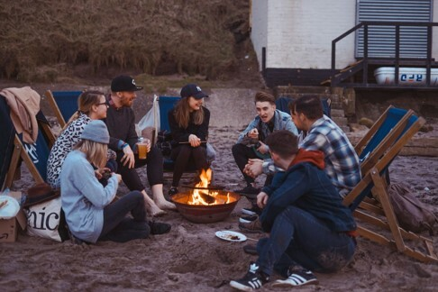

План ответа поможет вам:
— the place
— the action
— the appearance of the person
— whether you like the picture or not
Start with: “I’d like to describe picture № ... . The picture shows …”

Директорская контрольная работа 4
1 Прочитайте текст и заполните пропуски A–F частями предложений, обозначенными цифрами 1–7. Одна из частей в списке 1–7 лишняя.
Занесите цифры, обозначающие соответствующие части предложений в таблицу.
Number of teenagers with Saturday job drops
The number of teenagers with Saturday jobs has dropped. Young people do not acquire any experience for their CVs – a crucial step towards getting full-time work. The proportion of teenagers combining part-time jobs with school or college has slumped from 40% in the 1990s to around 20% now, according to the UK Commission for Employment and Skills (UKCES), a government agency. Latest figures show that only A______________ in 1997. The trend is not just recession-related, but the result of an increasing expectation B____________well as a falling number of Saturday jobs, according to the report. Many of the jobs that young people do, such as bar work, are in long-term decline, and are forecast to decline further over the next decade. "Recruiters place significant emphasis on experience … C_________________," the report says. Word of mouth is the most common way to get a job, D______________young people are unable to build up informal contacts, it adds.
Ms. Todd, a commissioner at the UKCES, said: "There's more emphasis on doing well at school, young people are finding less time to do what they would have done a few years ago. "I think it's also the changing structure of the labour market. Retail is still a big employer, E______________. As a consequence, we need to think about how we get young people the work experience they need."A new initiative to send employees into state schools to talk about their careers was also launched recently. The scheme, Inspiring the Future, is meant to give state schoolchildren access to the kind of careers advice that private schools offer. The deputy prime minister said: "The power of making connections
F______ and can be life-changing."
1. that young people should stay on at school, as
2. that inspire young people is immeasurable
3. but an increasing shortage of work experience means
4. but a lot more of it is being done online
5. 260,000 teenagers have a Saturday job compared with
435,000
6. that it was researching the system of funding education
after 16
7. but young people are leaving education increasingly less
experienced
2 Выполните грамматический тест

1. Maria__________ German at evening classes this term.
a. Is studying b. studies c. study d. does study

2. Ann asked how much ... on foot last.
a)do you spend b)I spend c)I had spend d)I spent
3. She is ... in her group.
a) shorter b) short c) the shortest
4. She has ... many friends.
a) such b)as c)so
5. .Takethe pen ... the shelf.
a) out of b) from c)up
6. I can’t afford it. I have too ... money for it.
a) little b) a little c) few d) a few
7. They said the car was ... .
a) their b) there’s c) theirs
8. .Does ... help you with the housework?
a) somebody b)nobody c) anybody
9. … will you stay in the town?
a)How long b)How much c)How many d)How far
10. It … that their marriage should take place in December.
a)was decided b)decided c)had decided
- Опишите одну из предложенных картинок

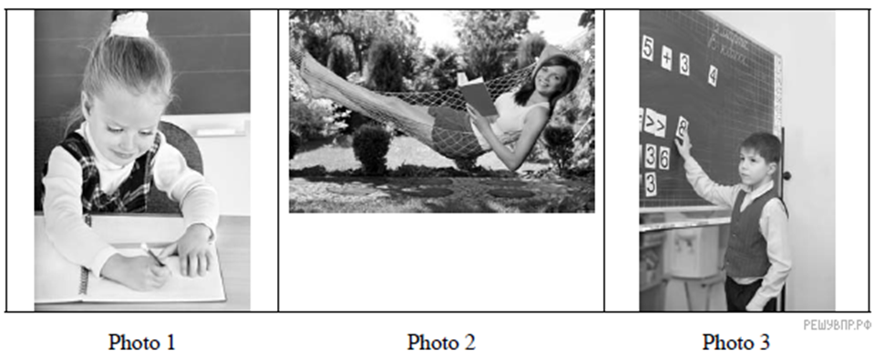
План ответа поможет вам:
— the place
— the action
— the appearance of the person
— whether you like the picture or not
Start with: “I’d like to describe picture № ... . The picture shows …”

